How To …

Create an Analytical List Page using CDS View

1 Purpose of the document 3
• Page Title 3
• Page Header 4
• Page Content 5
2 Create Analytical Model and Query for the ALP 6
2.1 Analytical Models Paradigm: 6
2.2 Create Dimensions CDS Views: 8
2.3 Create Cube CDS View: Z_CUBE_TURNOVER 11
2.4 Create Query CDS View: Z_QUERY_TURNOVER 12
Page Header (Visual Filter) 15
Page Content (Hybrid view) 17
3 Create Analytical List Page Application Z_TURNOVER_ALP: 21
3.1 Create ALP Sapui5 App: 21
3.2 Test the result: 30

Purpose of the document

Analytical List Page is a powerful Fiori Element, we can create with this template an analytical dashboard with KPIs, charts, tables and also a drill-down navigation to a detail page.
The structure of the ALP is composed by three main areas:
- Page Title
- Page Header
- Page Content

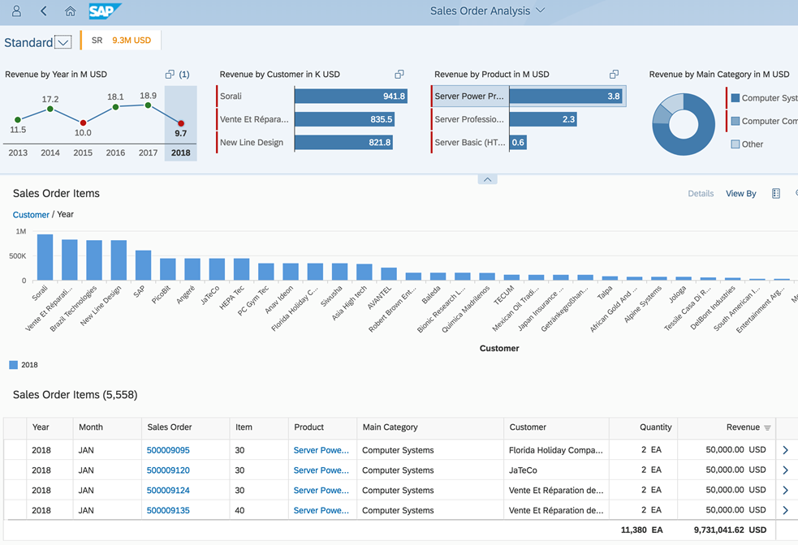

Page Title
Contains the variant management and a section of global KPI tags, it’s possible to display a maximum of three KPIs per application.
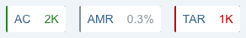

Pressing a KPI tag provides access to the KPI card which contains a chart with additional information, the KPI card is based on the same template of the analytical card provided by Overview Pages.

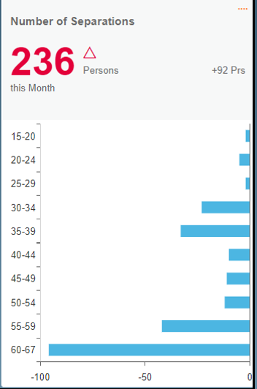

Page Header
Basically, composed by the filter area which allows users to filter the result set. Two types of filters are supported: compact filters and visual filters.
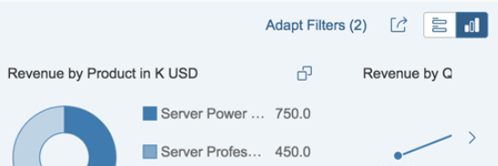

Visual filters are composed by a title and an interactive chart. When the user selects one point in the chart the content area is filtered based on the selected value, in the case of a hybrid view the chart and table are filtered at the same time.

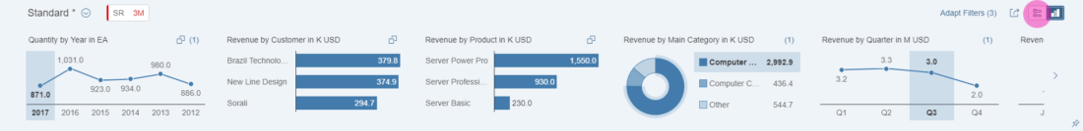

Page Content
Consists of either a hybrid view (combination of a chart and a table), a chart-only view, or a table-only view.
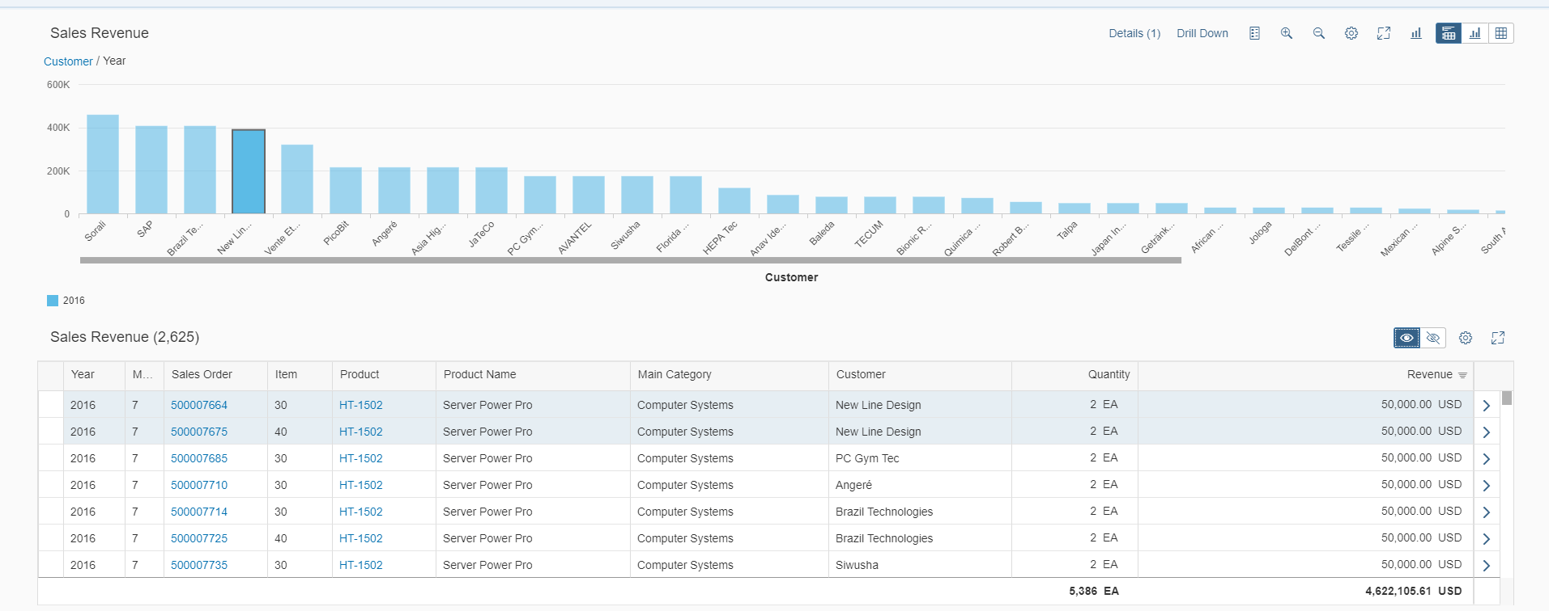

In the following Sections, we’ll describe how to create a Turnover ALP based on the CDS View P_Acdoca_Cube to demonstrate all of information presented above with the following Layout:

- Page Title
  - KPI Card with Turn Over per Company.
- Page Header
  - Visual Filter with Turn Over per Fiscal_Year.
  - Visual Filter with Turn Over per Profit Center.
- Page Content (Hybrid view)
  - Chart with Turn Over par Company / Fiscal_Year.
  - Table with Details of Turn Over per Company / Profit Center.
- Drill-down navigation
  - Object page with a simple form with the Company, Profit Center and Turnover.

Create Analytical Model and Query for the ALP

Analytical Models Paradigm:
The advantage of Analytical Models comparing Transactional is the using of aggregations to expose results across different areas (by time, by location…). These models are conceived over Facts and Dimensions and these views contain the basic data used to conduct detailed analyses and derive business values.

Note that in this document, we won’t focus on BI (Business Intelligence) concepts, however there is some basics notions on BI that we can define for more comprehension and ability to translate these concepts to ABAP CDS Views:

Considering as an example a purchasing turnover report which provides results based on supplier, product, date and Purchasing Group.

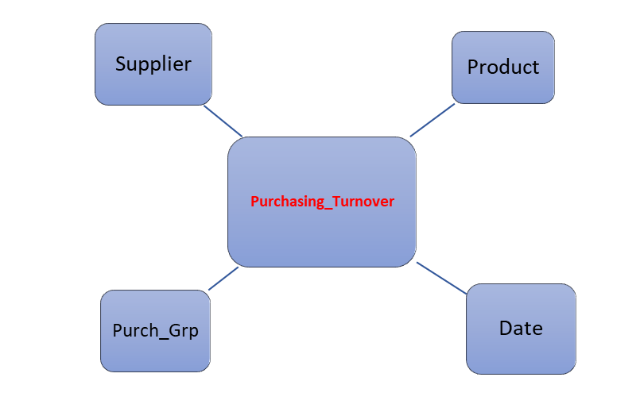

Fact: is the purchasing turnover itself and it holds values that we can measure (e.g Turnover per Purchasing Group and Total turnover per Purchasing Org…)

Dimensions: will be the filters which can be applied for the fact. (e.g by supplier, product, Purch_Group). These dimensions can have Attributes or Texts like (Supplier Name, Address, product Description…)

Cube: is the connection of all the elements above (Fact, Dimensions, Attributes) that it’s consequently an analytical model ready for consumption.

Query: is the exposition of the cube adapting the data in the way we want to expose to the user. So, the cube must be constructed in a way it can be reused and consumed by several different Queries.

For examples, with the purchasing model above we can create different queries:

- Turnover by products
- Turnover by Supplier
- Turnover by year quarter
- …

Now, we will focus to translate those BI concepts to ABAP CDS Views language respecting the following steps:

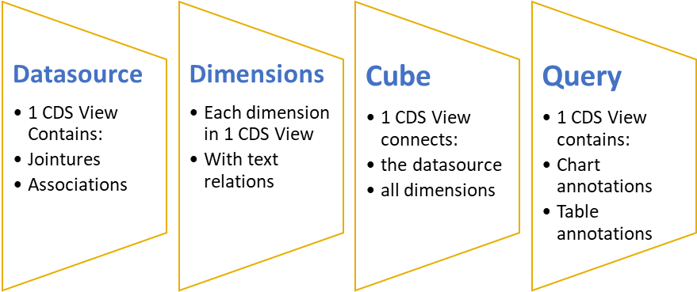

Step 1: Create a CDS View data source where we select all data we want to expose from tables and/or others CDS Views with all jointures and associations. In our example model, we use the CDS View P_ACDOCA which contains all the data we will use. But you can create a specific one respecting your need.

Step 2: Create the dimensions, each one in the form of CDS View. In our example, we will create 3 dimensions for Fiscal Year, Company and Profit Center.

Step 3: Create the Cube in one CDS View connecting the data source with all dimensions.

Step 4: Create the Query in one CDS View which contain all annotations required to generate our ALP application.

Facts (Measures) | Turnover (Total of Amount)
Dimension | - Company  - Profit Center  - Fiscal Year

Create Dimensions CDS Views:
All dimensions must have an @Analytics.dataCategory: #DIMENSION classification in the header of the view. Associations with texts and names are executed through annotation @ObjectModel.text.element.

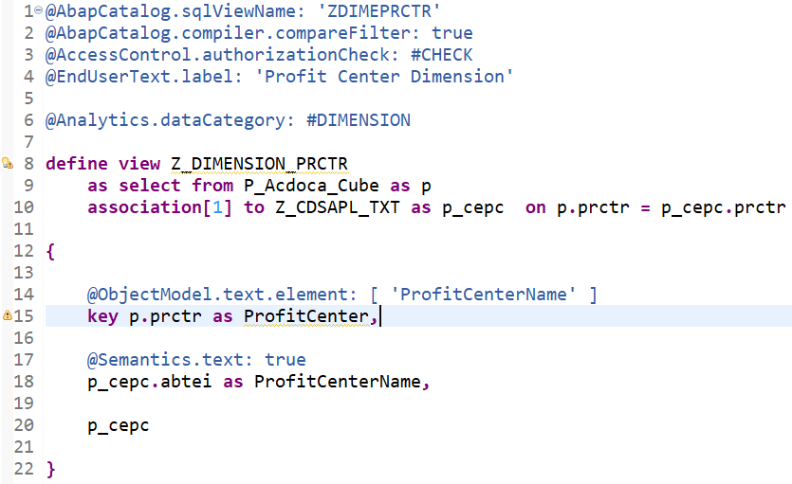

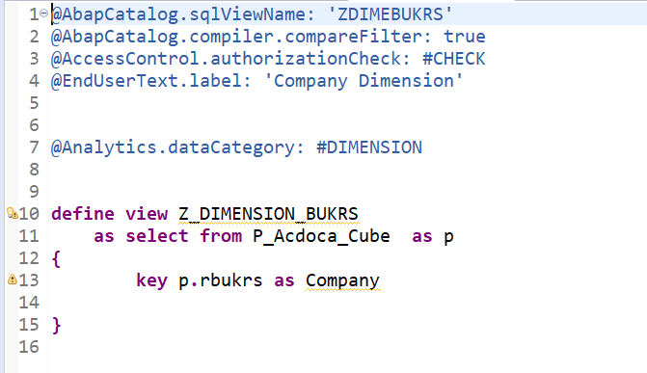

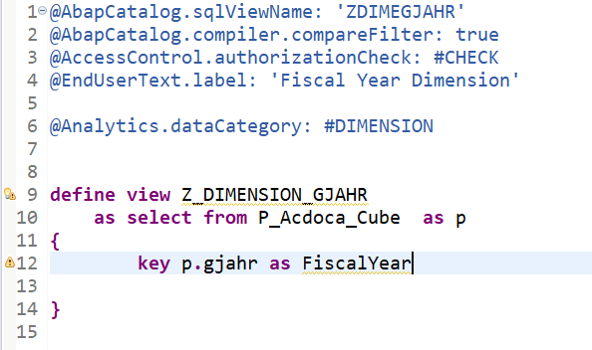

Note : it’s recommended to search for the standard dimension CDS Views created by SAP before generate a new CDS View, for our example we have created new CDS Views for demonstration but we can find the standard one below :

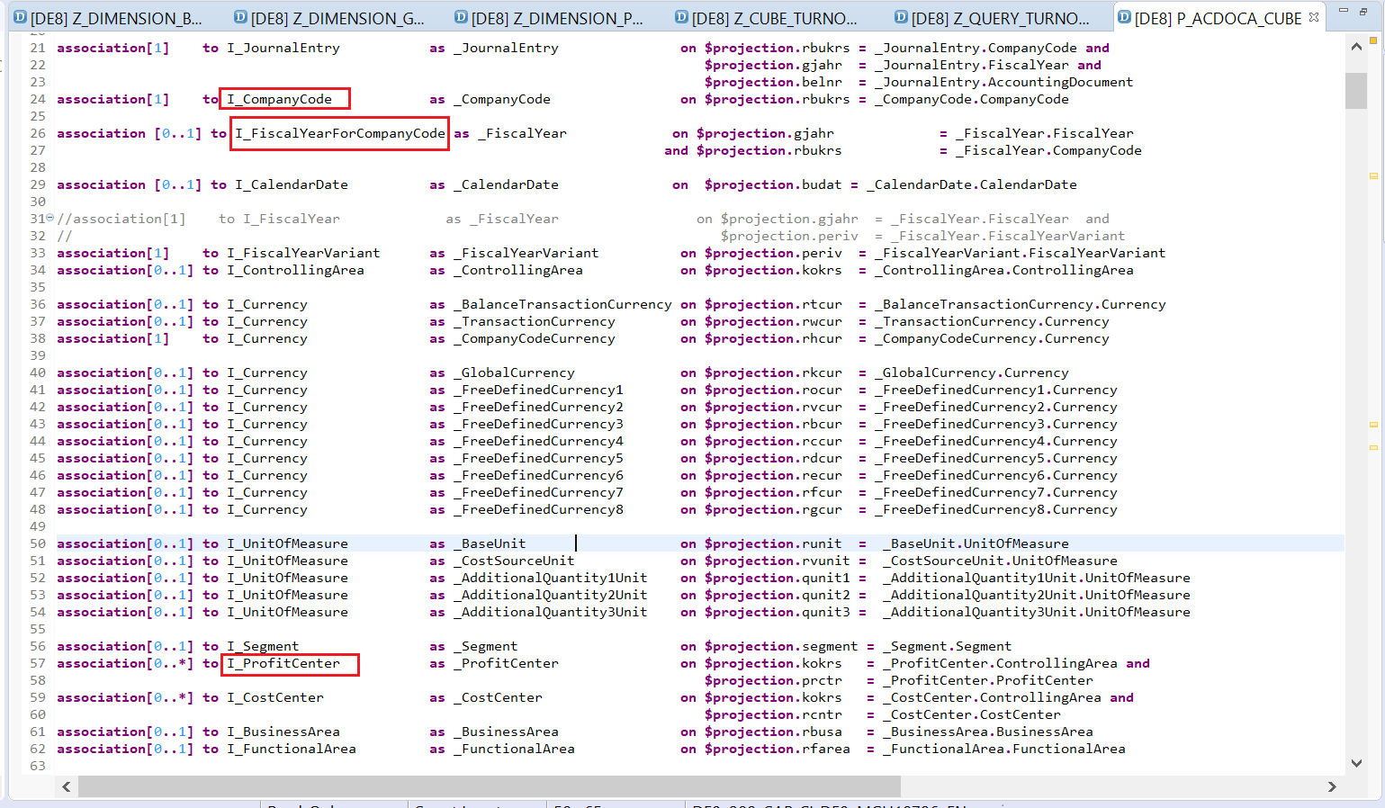

Create Cube CDS View: Z_CUBE_TURNOVER
The cube must have an @Analytics.dataCategory: #CUBE classification in the header of the view. @DefaultAggregation annotation should be place before the fields determined as measures.

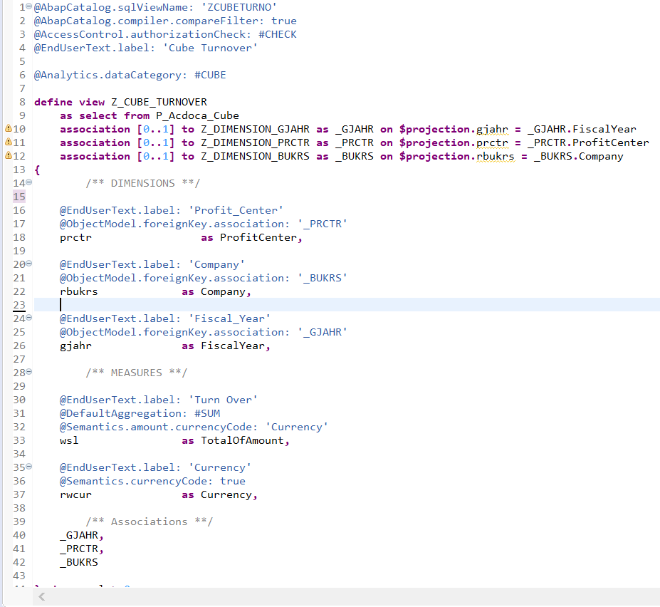

Create Query CDS View: Z_QUERY_TURNOVER
For more comprehension, we’ll divide the annotations code for each one the ALP Sections and combine all of them at the end of this topic.

Let’s begin:

Page Title (KPIs):

In this section we want only a KPI tag and card, check below the visualization of this section and the set of annotations expected to achieve this functionality.

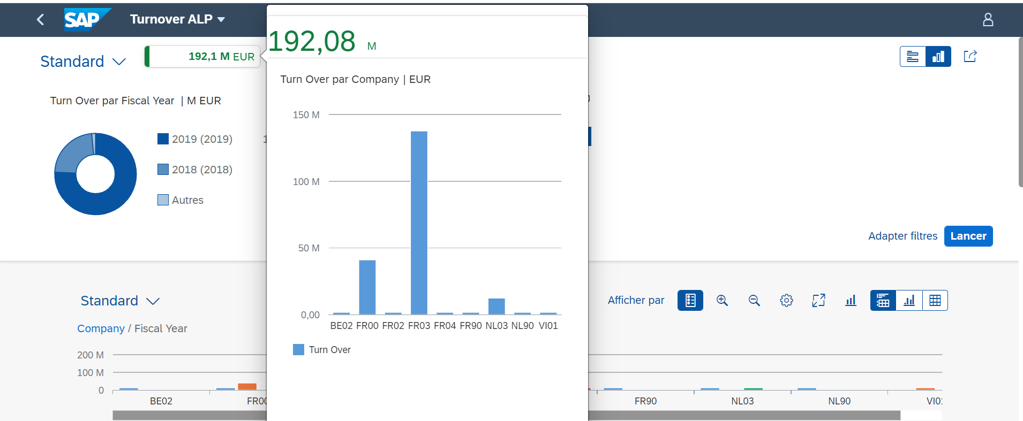

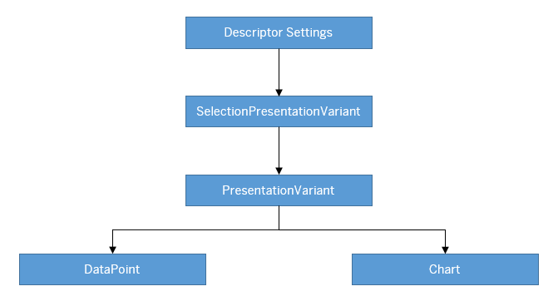

Below the annotations to be add in the Query CDS View to create the KPI chart :
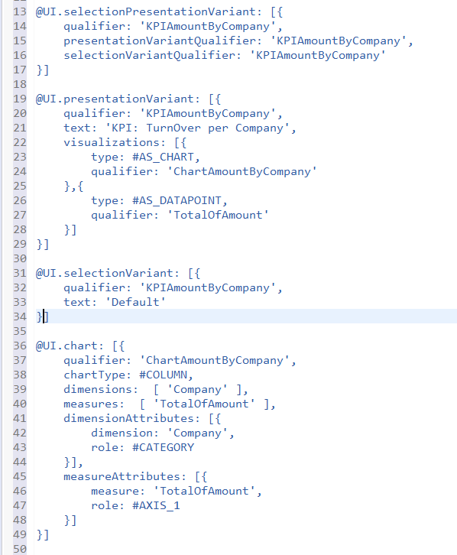

The datapoint has to be added via the @UI.dataPoint for the measures in the Query CDS :

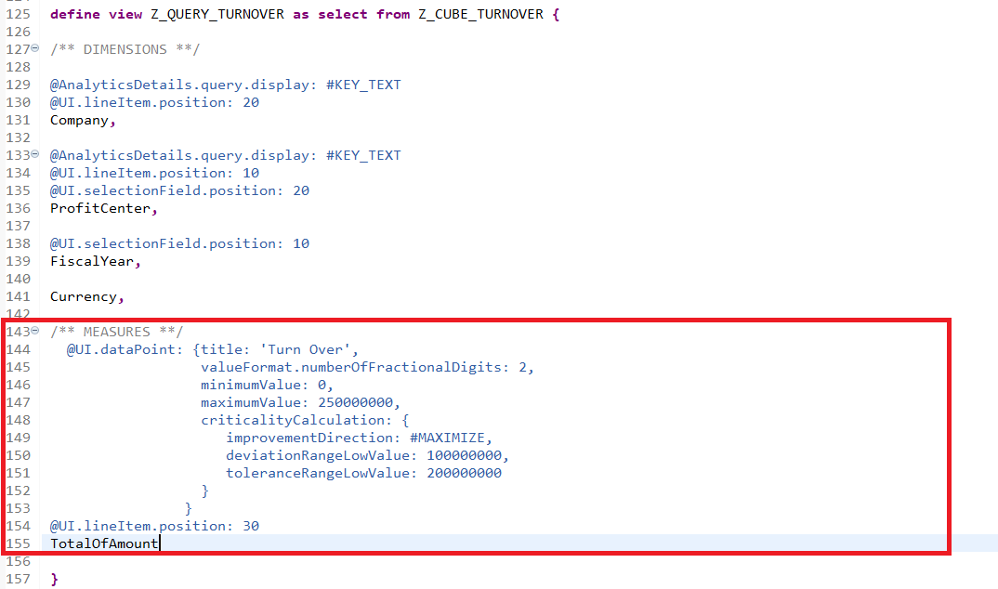

The properties minimumValue, maximumValue and criticalityCalculation are added to colorize the datapoint of the KPI according the criticality :

improvementDirection: The direction of the better value of measure

- Maximize : a maximizing measure where a higher value of a measure is better
- Minimze : a minimizing measure where a lesser value of a measure is better

Use the parameters below to specify the deviation and tolerance values :

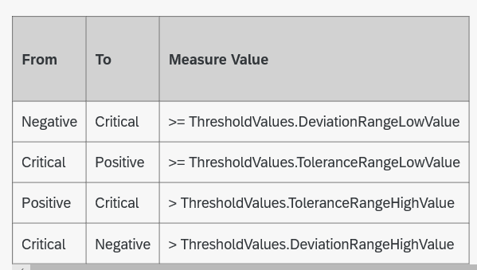

For our example above : We are used a maximize direction with

DeviationRangeLowValue : 100000000
ToleranceRangeLowValue : 200000000

< 100M >= < 200M >=

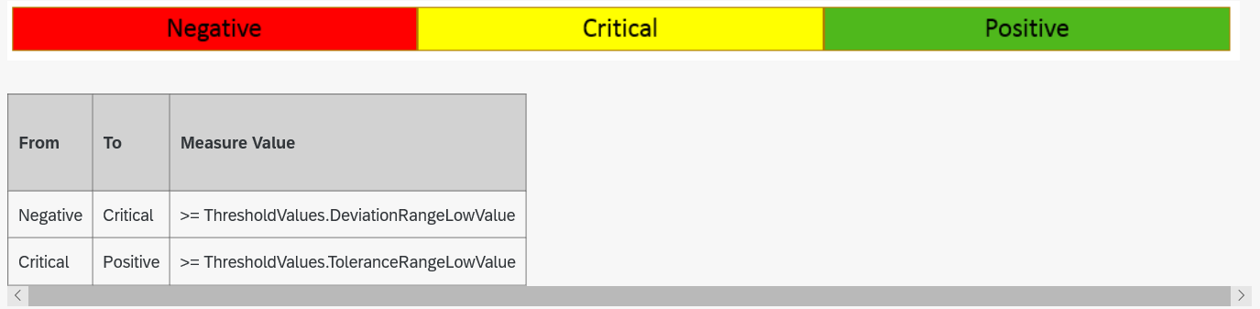

For more detail click here : https://sapui5.hana.ondemand.com/#/topic/02c53f4d9e58447db939546bed33fb44

Page Header (Visual Filter)

In this section, we will create two Charts with different type of visualization:

FilterAmountByYear (Donut)
FilterAmountByProfitCenter (HORIZONTAL_AREA)

To include the visual filter attribute, we check below the visualization of this section and set of annotations expected for the visual filter below:

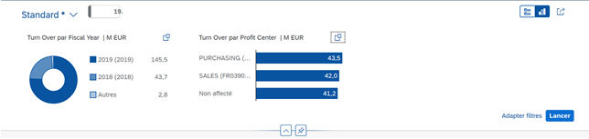

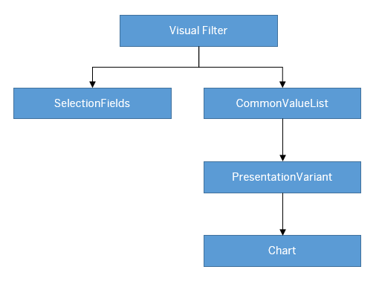
Below the annotations to be add in the Query CDS View to create the filter charts :

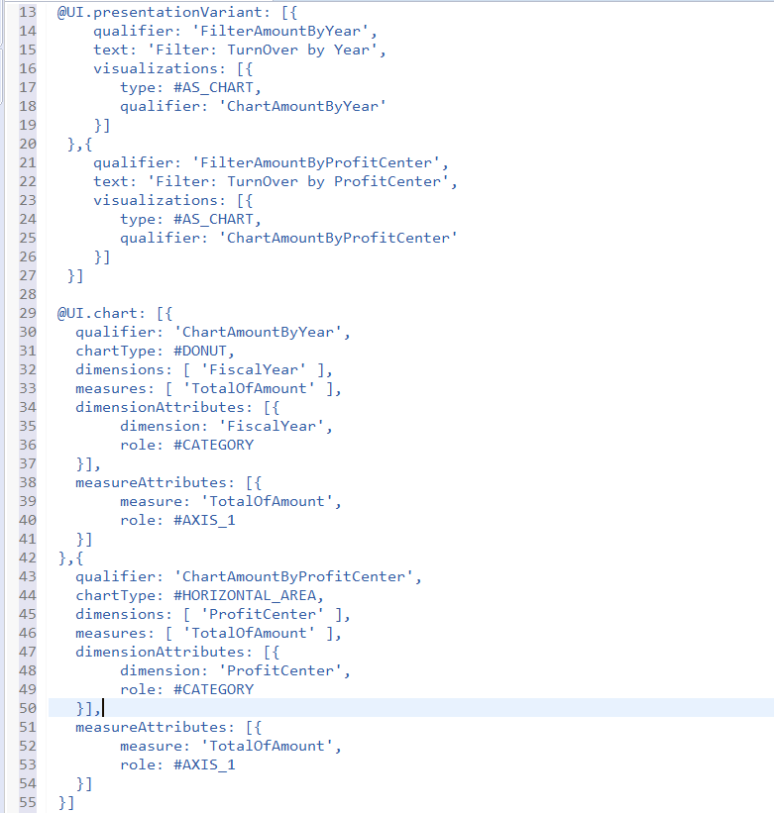

Note: We’ll add the CommonValueList annotation for each Filter directly in the annotation file inside the UI5 application because we could not add it in the CDS View.

Page Content (Hybrid view)

Finally, let’s add the chart and table annotations for the page content. Check below the visualization of this section and the expected set of annotations for each one of them:

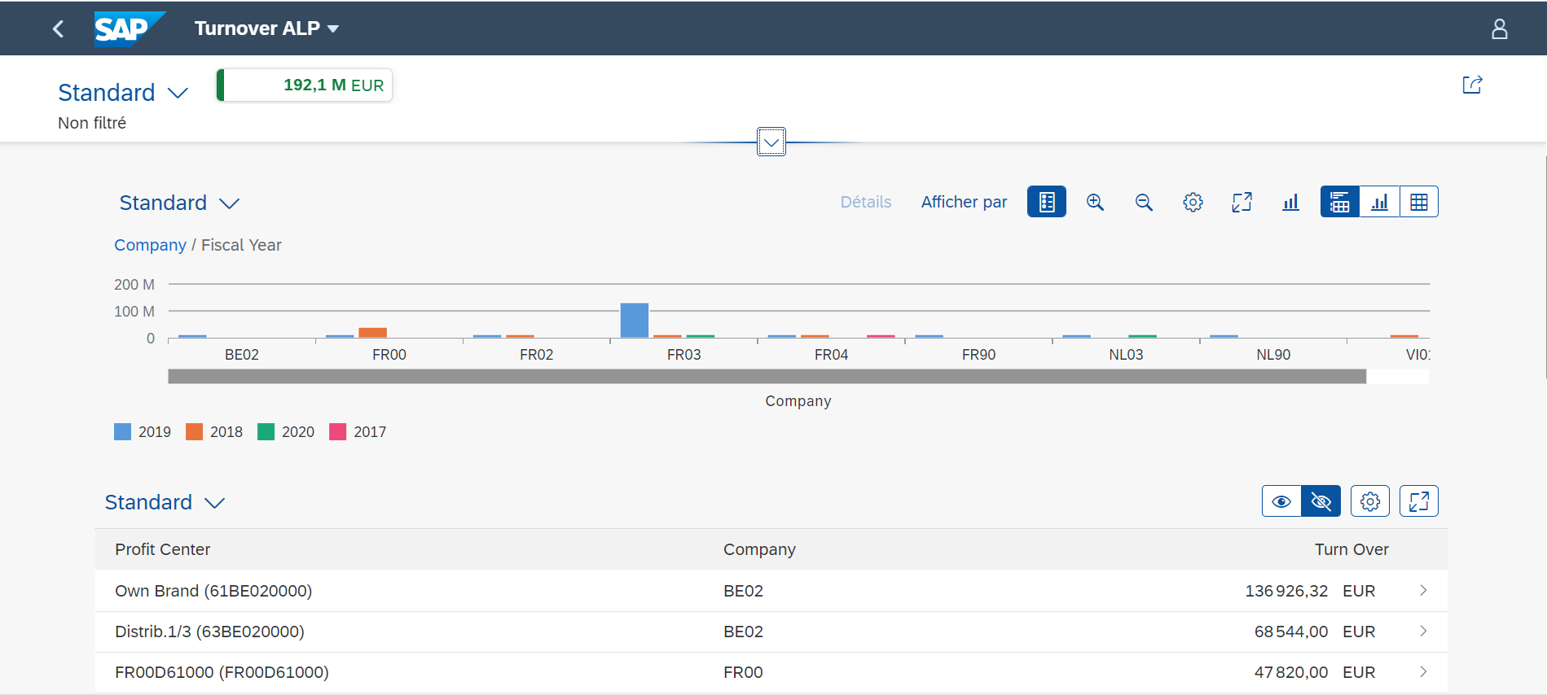

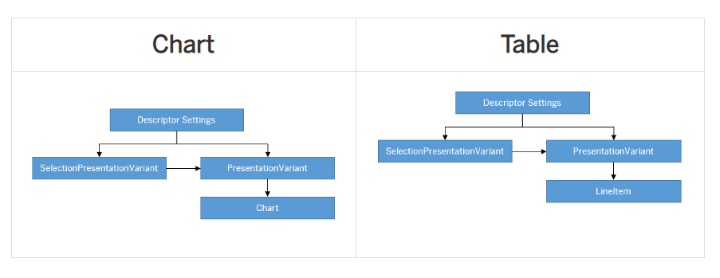

Below the annotations to be add in the Query CDS View to create the Hybrid chart/table in the content of page:

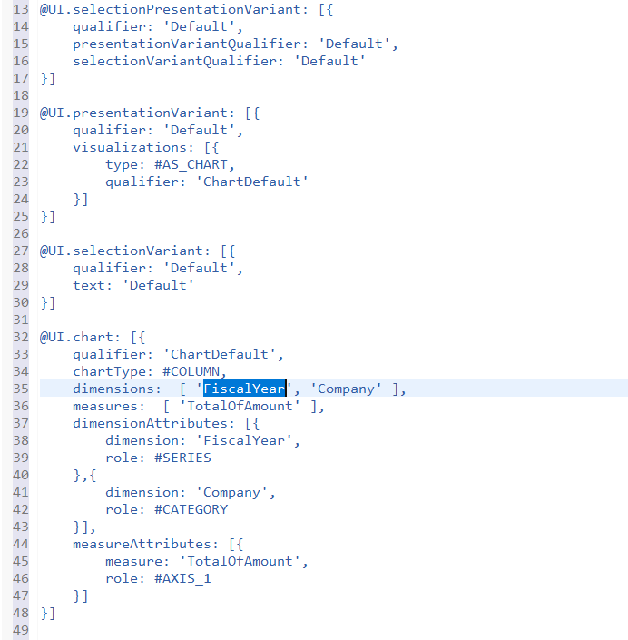
To create a table, we need to include annotations for each one of the columns:

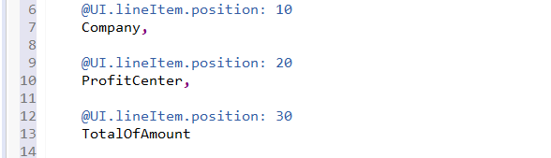

Now we combine all the parts of the annotations to the Query CDS View Below :

Note :

- Don’t forget to place the annotation @Analytics.query: true to transform this CDS view in an analytical query.
- Place the @OData.publish: true in the header to publish an OData service project automatically based on the structure of our CDS view.

@AbapCatalog.sqlViewName: 'ZQUERYTO'
@AccessControl.authorizationCheck: #CHECK
@EndUserText.label: 'Turnover Query'
@AbapCatalog.compiler.compareFilter: true

@Analytics.query: true
//@Analytics: { dataExtraction.enabled: true, query: true }
@VDM.viewType: #CONSUMPTION
@OData.publish: true

@UI.selectionPresentationVariant: [{
qualifier: 'KPIAmountByCompany',
presentationVariantQualifier: 'KPIAmountByCompany',
selectionVariantQualifier: 'KPIAmountByCompany'
},{
qualifier: 'Default',
presentationVariantQualifier: 'Default',
selectionVariantQualifier: 'Default'
}]

@UI.presentationVariant: [{
qualifier: 'KPIAmountByCompany',
text: 'KPI: TurnOver Per Company',
visualizations: [{
type: #AS_CHART,
qualifier: 'ChartAmountByCompany'
},{
type: #AS_DATAPOINT,
qualifier: 'TotalOfAmount'
}]
},{
qualifier: 'FilterAmountByYear',
text: 'Filter: TurnOver by Year',
visualizations: [{
type: #AS_CHART,
qualifier: 'ChartAmountByYear'
}]
},{
qualifier: 'FilterAmountByProfitCenter',
text: 'Filter: TurnOver by ProfitCenter',
visualizations: [{
type: #AS_CHART,
qualifier: 'ChartAmountByProfitCenter'
}]
},{
qualifier: 'Default',
groupBy: ['Company'],
visualizations: [{
type: #AS_CHART,
qualifier: 'ChartDefault'
}]
}]

@UI.selectionVariant: [{
qualifier: 'KPIAmountByCompany',
text: 'KPI Turnover By Company'
},{
qualifier: 'Default',
text: 'Default'
}]

@UI.chart: [{
qualifier: 'ChartAmountByCompany',
chartType: #COLUMN,
dimensions: [ 'Company' ],
measures: [ 'TotalOfAmount' ],
dimensionAttributes: [{
dimension: 'Company',
role: #CATEGORY
}],
measureAttributes: [{
measure: 'TotalOfAmount',
role: #AXIS_1
}]
},{
qualifier: 'ChartAmountByYear',
chartType: #DONUT,
dimensions: [ 'FiscalYear' ],
measures: [ 'TotalOfAmount' ],
dimensionAttributes: [{
dimension: 'FiscalYear',
role: #CATEGORY
}],

measureAttributes: [{
measure: 'TotalOfAmount',
role: #AXIS_1
}]
},{
qualifier: 'ChartAmountByProfitCenter',
chartType: #HORIZONTAL_AREA,
dimensions: [ 'ProfitCenter' ],
measures: [ 'TotalOfAmount' ],
dimensionAttributes: [{
dimension: 'ProfitCenter',
role: #CATEGORY
}],

measureAttributes: [{
measure: 'TotalOfAmount',
role: #AXIS_1
}]
},{
qualifier: 'ChartDefault',
chartType: #COLUMN,
dimensions: [ 'FiscalYear', 'Company' ],
measures: [ 'TotalOfAmount' ],
dimensionAttributes: [{
dimension: 'FiscalYear',
role: #SERIES
},{
dimension: 'Company',
role: #CATEGORY
}],
measureAttributes: [{
measure: 'TotalOfAmount',
role: #AXIS_1
}]
}]

define view Z_QUERY_TURNOVER as select from Z_CUBE_TURNOVER {

/** DIMENSIONS **/

@AnalyticsDetails.query.display: #KEY_TEXT
@UI.lineItem.position: 20
Company,

@AnalyticsDetails.query.display: #KEY_TEXT
@UI.lineItem.position: 10
@UI.selectionField.position: 20
ProfitCenter,

@UI.selectionField.position: 10
FiscalYear,

Currency,

/** MEASURES **/
@UI.dataPoint: {title: 'Turn Over', valueFormat.numberOfFractionalDigits: 2}
@UI.lineItem.position: 30
TotalOfAmount

}

Create Analytical List Page Application Z_TURNOVER_ALP:

Create ALP Sapui5 App:
In WebIDE, we create a new project from template choosing SAP Fiori Elements category and selecting the Analytical List Page.

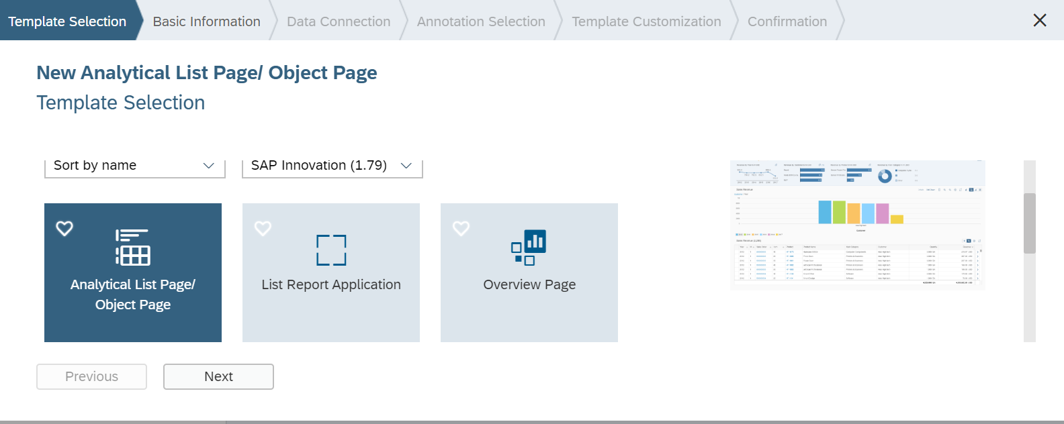

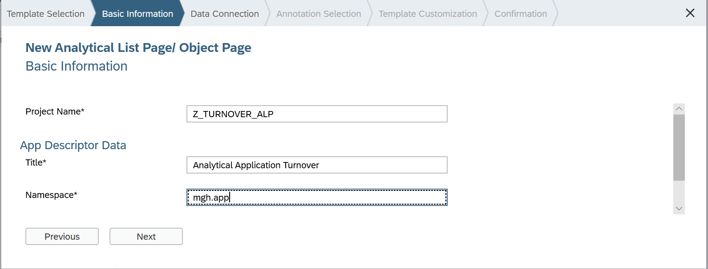

- Select the OData service Z_QUERY_TURNOVER_CDS created in the previous section from service catalog :
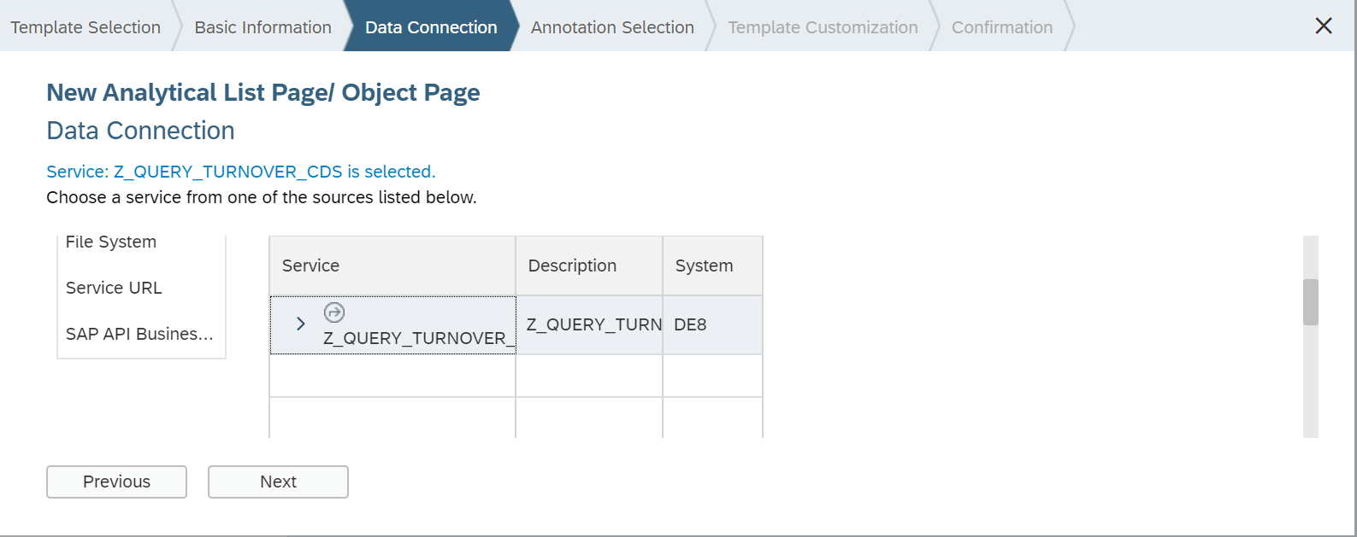

- Select the remote annotation file to expose the annotations generated through the ABAP CDS view:
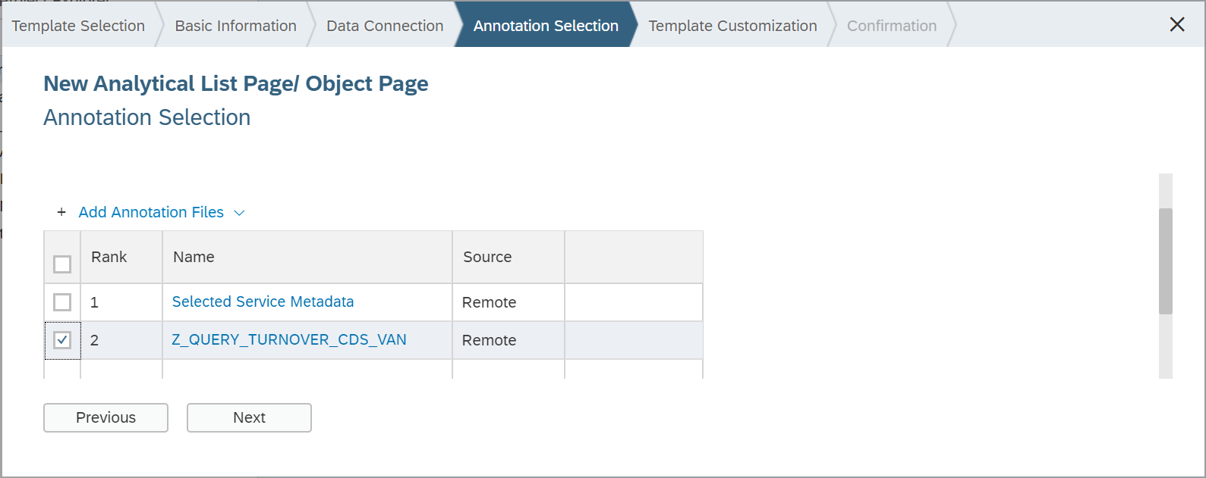

- Define the template customizing:
  - OData Collection: Z_QUERY_TURNOVER
  - Qualifier: Default
  - Table Type: Responsive
  - Auto Hide: True

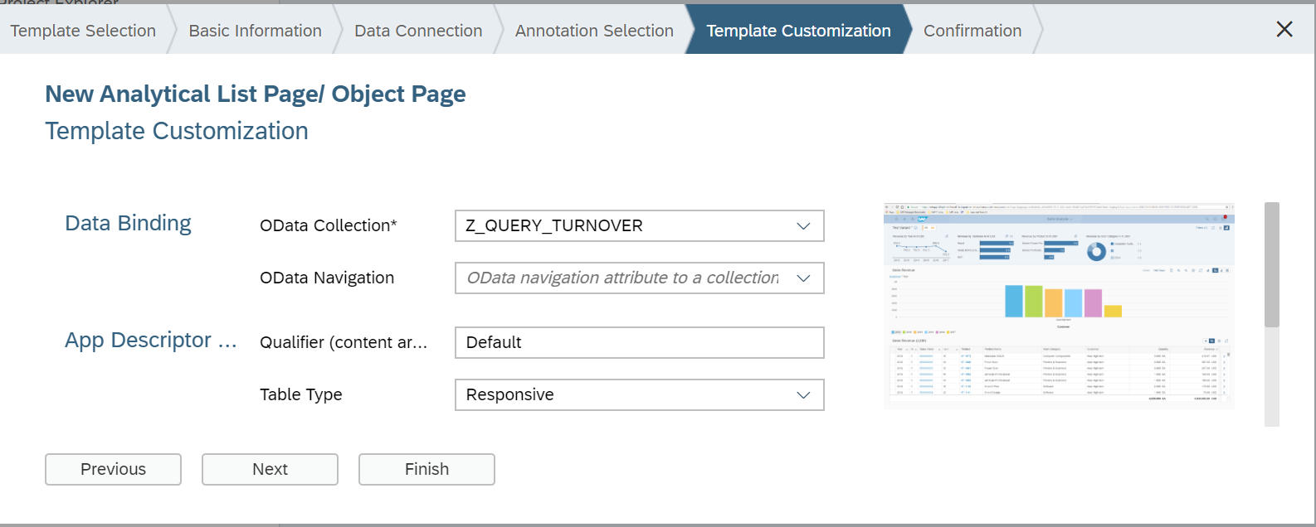

- Press Finish to conclude the Web IDE wizard. And the structure of the project will be:

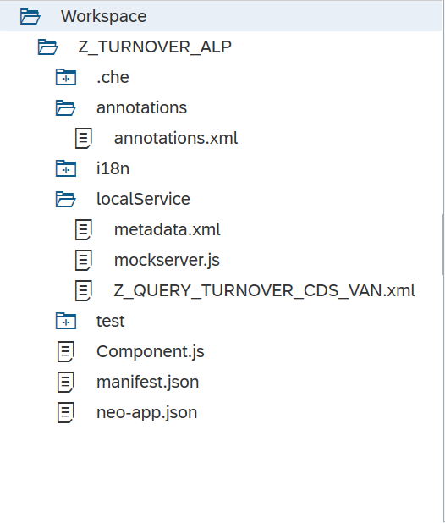
After generating the project, we can find the following code inside the App descriptor manifest.json for the Analytical List Page in the section sap.ui.generic.app generated automatically :

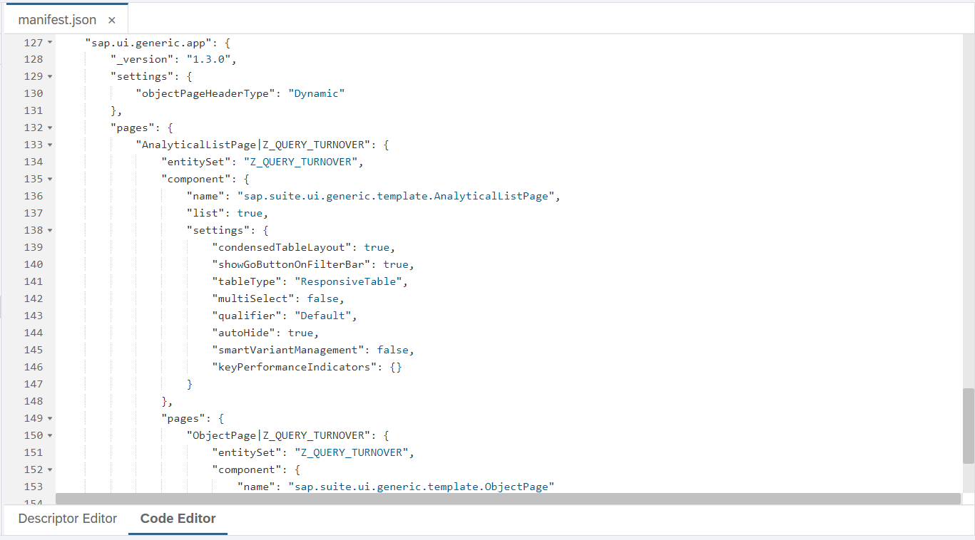

We have to include some configurations in the app descriptor and in the local annotation file:

- KPI tag and card (manifest.json)
- Visual filter (annotation.xml)
- Object page (annotation.xml)

Kpi: we add this snippet of code inside the keyPerformanceIndicators attribute:

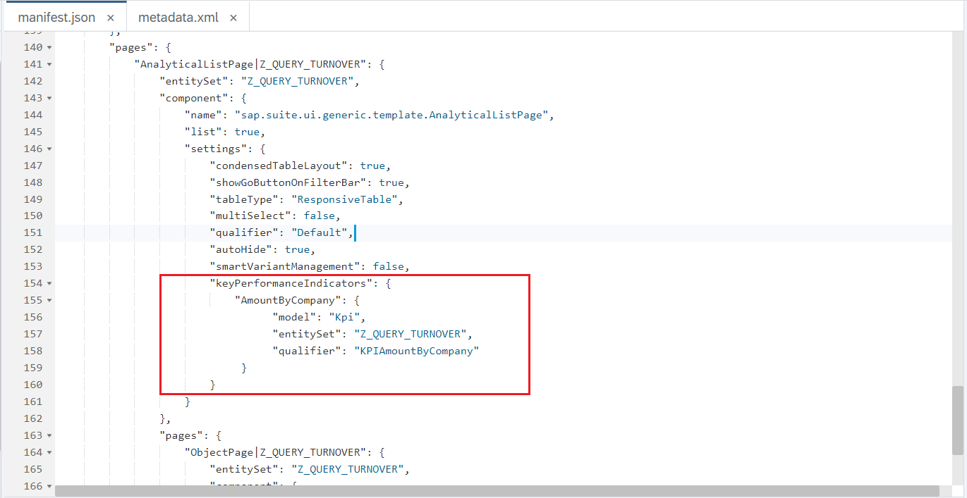

We have to create a new model called Kpi pointing to our data source:

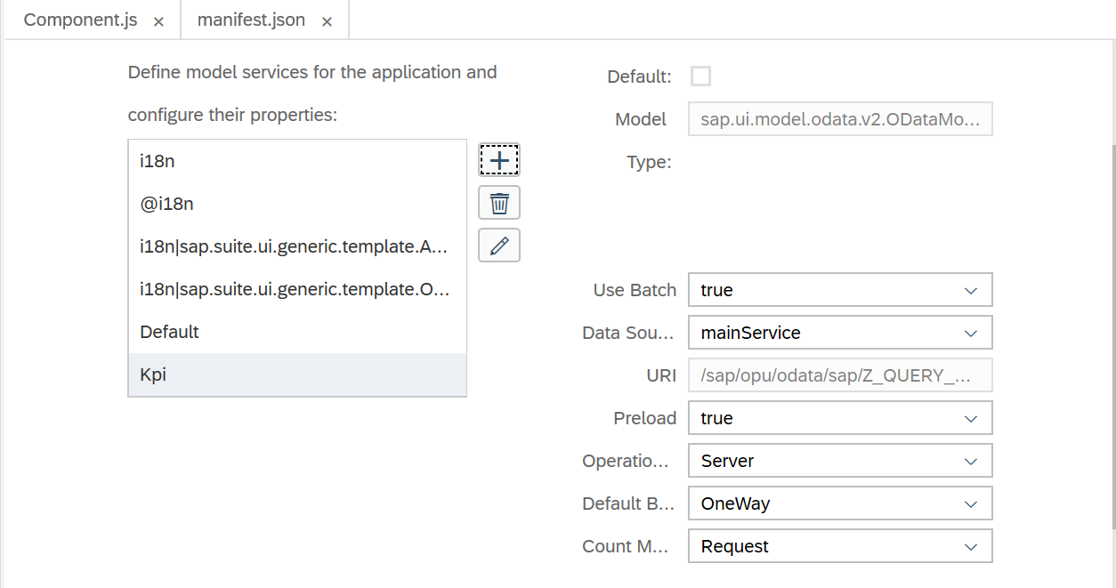

Visual Filter: Configure a Common.ValueList annotation for the property FiscalYear and ProfitCenter. We use the annotation modeler; you can also configure directly in the XML code.

In the annotation modeler select a new Target for the property FiscalYear:

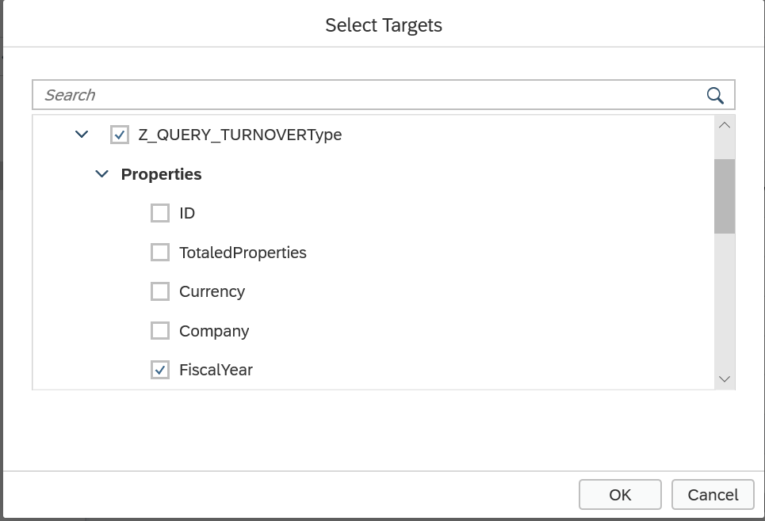

Add a new Common.ValueList annotation and fill the following attributes:
- CollectionPath: Z_QUERY_TURNOVER
- PresentationVariantQualifier: FilterAmountByYear

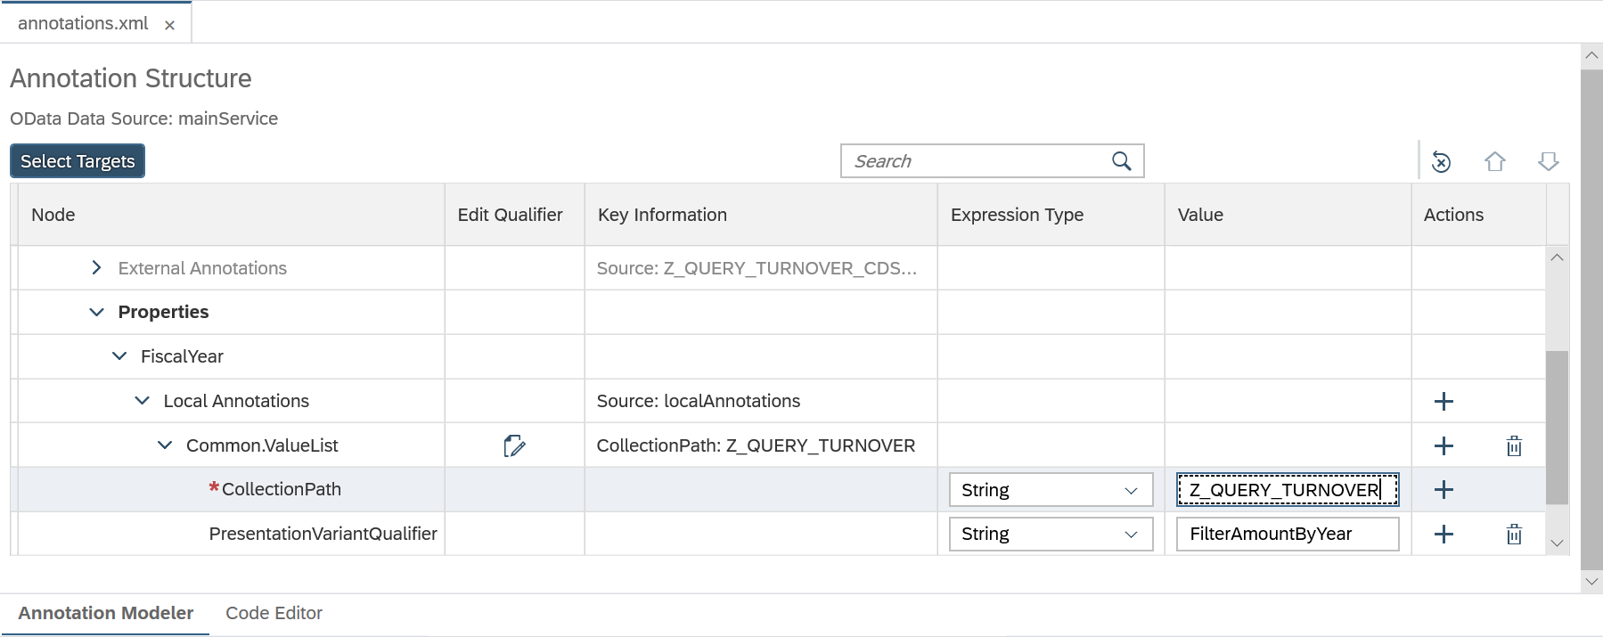

The part of the XML code generated:

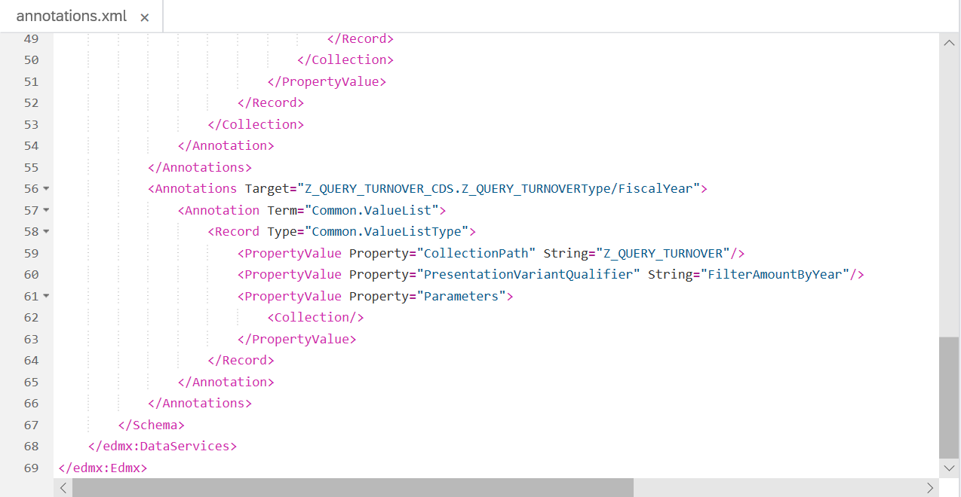

Do the same thing above for the property ProfitCenter.

Object Page (Detail View): Add a new group of Facet annotations with the following attributes:

UI.CollectionFacet
- ID: GeneralInformation
- Label: Details (i18n string)
- UI.ReferenceFacet
  - Target: @UI.lineItem

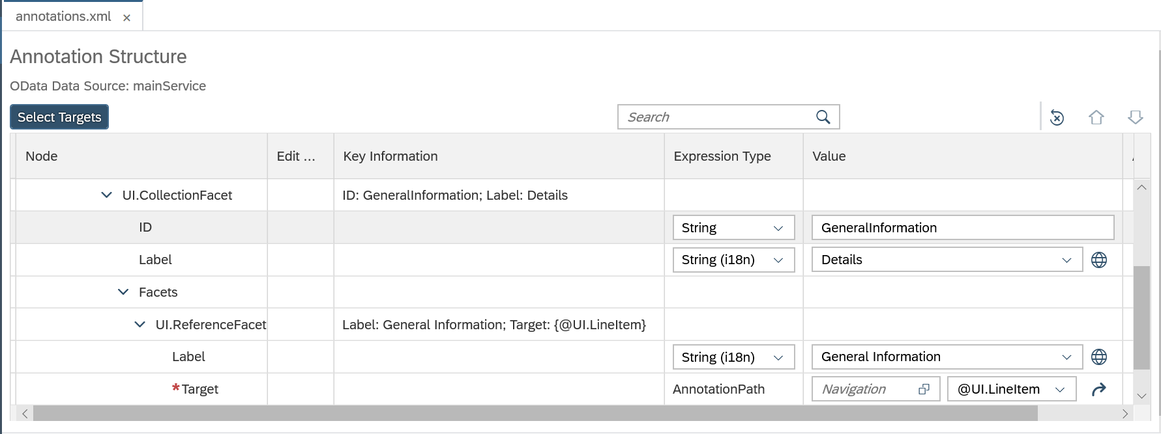

The code XML generated :

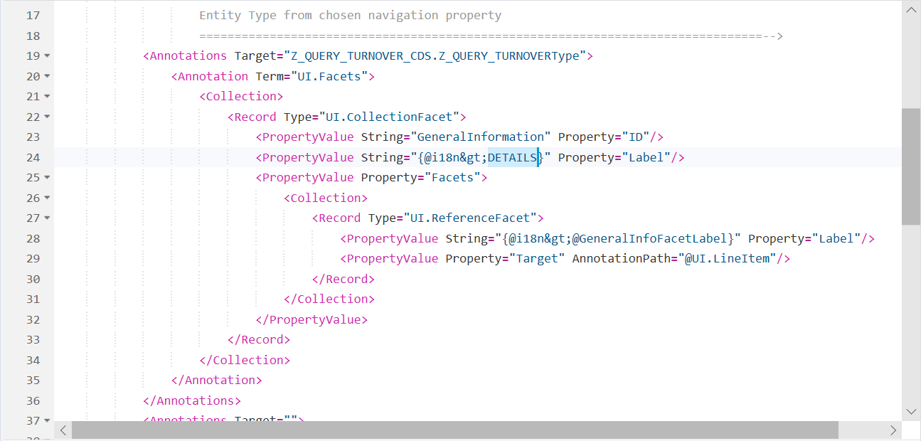

Test the result:

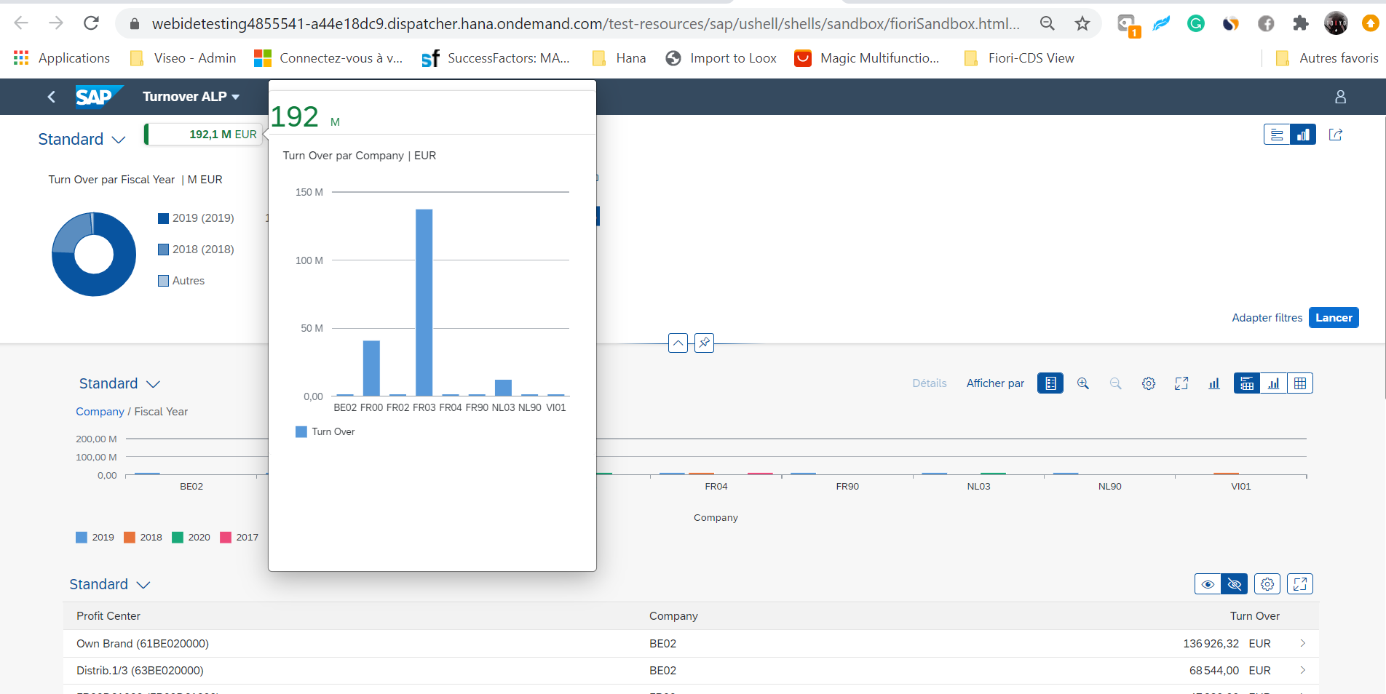

By clicking on a line, we display its detail :

